Methods grid design in Tånga Hed

Questions: Is predation more determined by the density of the host plant or by the density of the host ant? How is predation and fitness related to temperature / moisture? Is predation in an individual plant dependent on the density of neighboring conspecific plants / density of phenological stages suitable for oviposition? How does this affect fitness? …

* 1st VISIT (9-17 July):

MARKING OF PLOT AND GRID: The plot will be located on the area where we sampled plants last year. Start with a 45 x 45 m plot, containing 225 3 x 3 m squares (thus a grid of 256 points, separated among each other by 3 m, marked with cut broom sticks every 15 m, and blompinnar in between (every 3 m). Put a sign saying what is happening in one of the broom sticks.

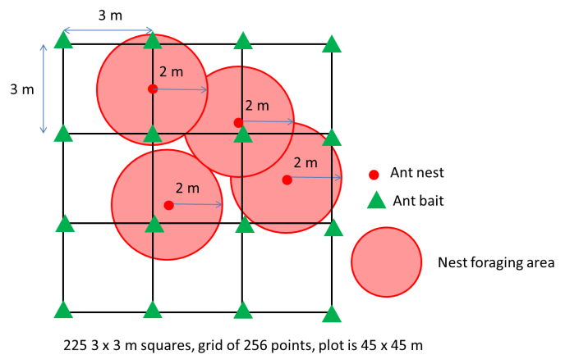

INSTALLATION OF LOGGERS: Install one iButton at each point, buried into the soil, in the same direction (e.g. 5 cm north of the marking stick, note if installed differently), previously set to log every 3 hours. Install also 16-25 loggers for measuring air temperature, covered with a plastic cup attached to the stick with Dutch tape

MOISTURE MEASUREMENTS: Take one measure at each point (either on 1st or 2nd visit), avoiding rainy days

MARKING OF PLANTS + MEASUREMENTS OF TRAITS, INTERACTION INTENSITY, CONTEXT: Mark 4-5 plants per square (depending on development some could also be marked in the next visit). Mark with wool and tape label with square number + plant number (e.g. 1.1) around the most advanced shoot. For each marked plant, count and note in the protocol the number of shoots, and count number of flowers (i.e. count of all buds + open and dry flowers). Measure also vegetation height around the plant (cm). Count number of eggs on the whole shoot.

1st ANT COLLECTION: Set one bait at each point as on the previous experiment. Label with adhesive label + pencil with Location, Date, Point number.

* 2nd VISIT (29 July-5 August):

MAPPING: Use blue rope to delimitate the squares. For each of the 3 x 3 m squares, map all reproductive shoots (i.e. shoots that have open or dry flowers, or buds), and note the developmental stage of the most advanced bud (stages a-f) and the number of eggs on the whole shoot (see how long it takes to count all, if it is very long try estimating or making categories).

MEASUREMENTS OF TRAITS, INTERACTION INTENSITY, (FITNESS) ON MARKED PLANTS: Mark more plants if needed. For the selected shoot in each marked plant, measure shoot height (cm) and note the developmental stage of the most advanced bud (stages a-f) and the number of intact / predated / aborted buds / flowers / fruits (if present). Count again number of eggs on the whole shoot.

2nd ANT COLLECTION

* 3rd VISIT (30 August-):

MEASUREMENTS OF INTERACTION INTENSITY, FITNESS ON MARKED PLANTS: For the selected shoot in each marked plant, count and note number of intact / predated / aborted buds / flowers / fruits (if present). Count again number of eggs on the whole shoot (if needed).

FRUIT COLLECTION: Collect one fruit of each type (predated / unpredated) from the selected shoot in each marked plant when available.

3rd ANT COLLECTION (if needed, depending on the amount of samples already collected).

Remove everything from Tånga Hed (cows on 1st- 5th September).